**GROUP 9**

**EXPERIMENT 7**

**OBJECTIVE:** SERVOMOTOR SPEED CONTROL USING BLYNK APP

**BLOCK DIAGRAM:**

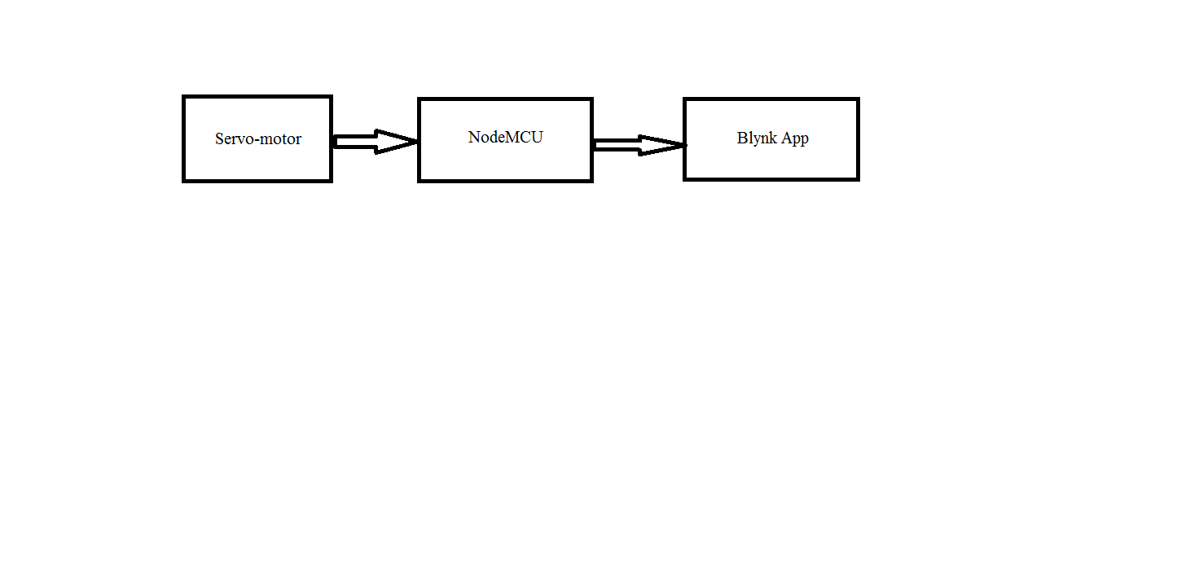

**Fig 1A**

**EXPLANATION:**

Servo motor works by pulse-width modulation, through the control wire, by an electrical pulse of variable width. The motor can turn 90o usually, for a total movement of 180o .

**APPARATUS:**

* Servo-motor
* Jumper wires
* NodeMCU
* Micro USB cable
* Blynk app

**PROGRAM:**

#define BLYNK_PRINT Serial

#include <ESP8266WiFi.h>

#include <BlynkSimpleEsp8266.h>

#include <Servo.h>

char auth[] = "VMxWkaMAVaKkDvZQ_S8hAE_s1suoji8_";

char ssid[] = "Codermaker";

char pass[] = "babi1pal";

Servo servo;

BLYNK_WRITE(V3) {

servo.write(param.asInt());}

void setup() {

Serial.begin(115200);

Blynk.begin(auth, ssid, pass);

servo.attach(2); // 15 means D8 pin of ESP8266

}

void loop()

{

Blynk.run(); // You can inject your own code or combine it with other sketches.

}

**RESULT**:

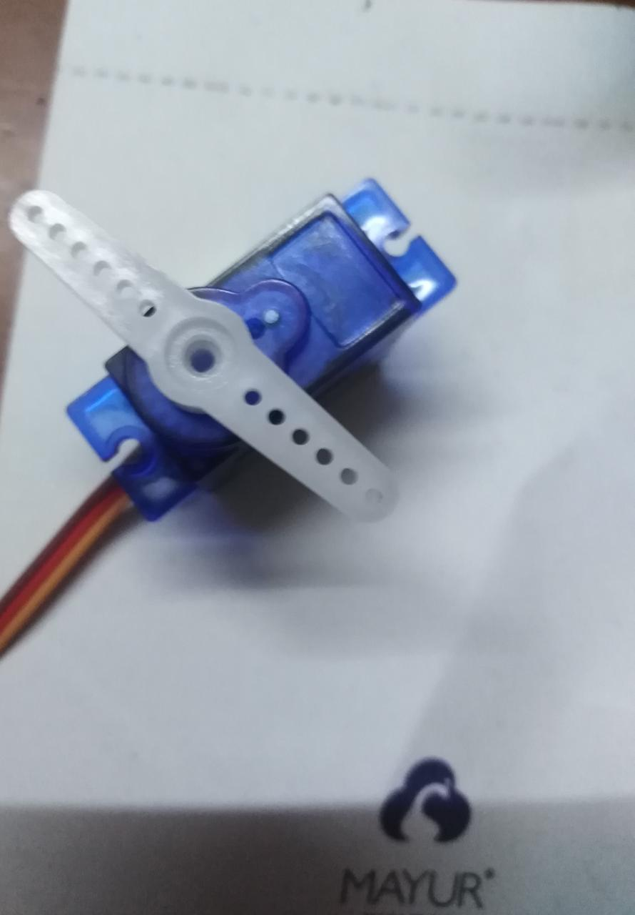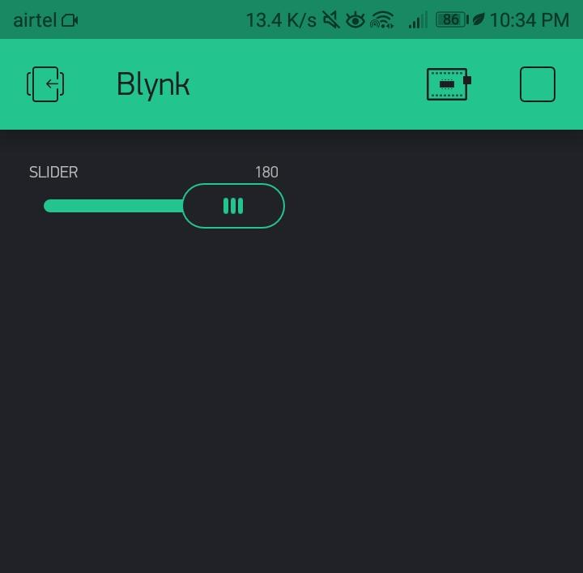

**Fig 1B**